SHOPIFY STOCK PERFORMANCE ANALYSIS USING POWER BI
Submitted by: Priyadharshini B

1. Introduction
This project analyzes historical Shopify stock data using Microsoft Power BI. An interactive dashboard was created to study stock prices, trading volume, daily returns, and yearly performance using different charts, KPI cards, and slicers.

2. Objectives
- Analyze Shopify stock price data.
- Study Open, High, Low, and Close prices.
- Examine trading volume and daily returns.
- Compare current and previous-year closing prices.
- Analyze monthly, quarterly, and yearly trends.
- Create an interactive Power BI dashboard.

3. Dataset Description
The dataset contains historical Shopify stock information.
Main fields: Date, Open, High, Low, Close, Adjusted Close, and Volume.
Column | Description
Date | Trading date
Open | Opening price
High | Highest price
Low | Lowest price
Close | Closing price
Adj Close | Adjusted closing price
Volume | Shares traded

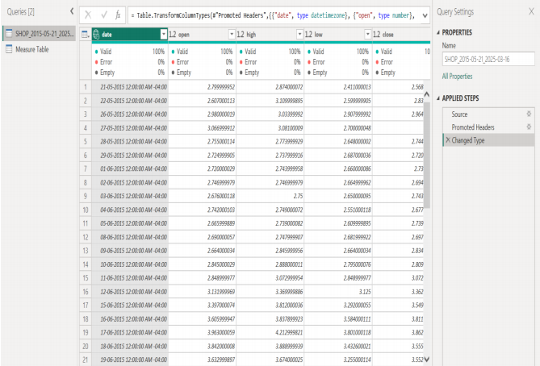
4. Data Preparation
The dataset was imported into Power BI and prepared using Power Query. Data types were checked and assigned appropriately for accurate analysis.

5. Date Table
A separate Date Table was created with Date, Day, Month, Month Number, Quarter, and Year fields. It supports monthly, quarterly, and yearly analysis.

6. Relationship
The Date Table was connected to the Shopify Stock table using the Date column. This relationship supports accurate time-based calculations and visualizations.
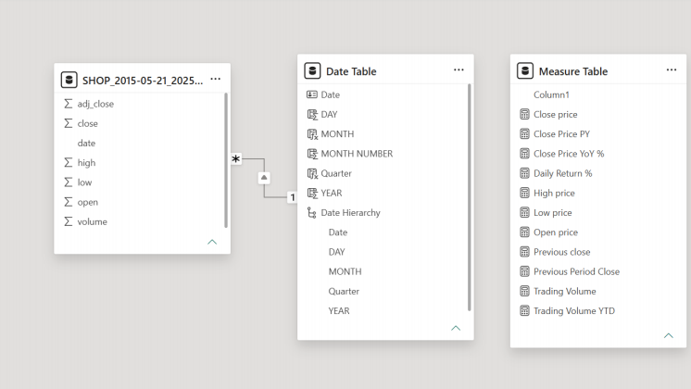

7. DAX Measures
The following measures were created:
- Close Price
- Open Price
- High Price
- Low Price
- Trading Volume
- Previous Close
- Daily Return %
- Previous Period Close
- Close Price PY
- Close Price YoY %
These measures were used in KPI cards and dashboard visuals.

8. Dashboard Visualizations
The dashboard includes:
- KPI Cards – Display key stock indicators.
- Date Slicer – Filters the dashboard by date.
- Close Price by Date – Shows price movement over time.
- Daily Return % – Displays daily stock changes.
- Trading Volume by Date – Shows trading activity.
- Close Price by Year – Compares yearly performance.
- Close Price vs Close Price PY – Shows previous-year comparison.
- Close Price by Month – Displays monthly variations.
- Trading Volume by Quarter – Compares quarterly activity.
- Open Price vs Close Price – Compares opening and closing prices.
- Low Price vs High Price – Shows yearly price ranges.
- Close Price by Year – Pie Chart – Compares yearly values.

9. Final Dashboard
The final dashboard combines KPI cards, slicers, line charts, column charts, donut charts, and pie charts into an interactive report for analyzing Shopify stock performance.
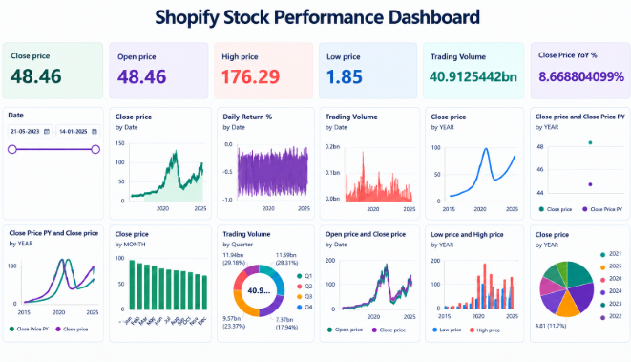

10. Key Observations
- Stock prices vary across different periods.
- Open and close prices can be compared through the charts.
- High and low prices show stock price ranges.
- Trading volume changes across dates and quarters.
- Daily Return % shows short-term variations.
- Previous-year comparison helps analyze yearly changes.
- Monthly and quarterly charts reveal time-based patterns.

11. Conclusion
This project demonstrates how Power BI can be used to transform Shopify stock data into an interactive dashboard. Data preparation, Date Tables, relationships, DAX measures, KPI cards, slicers, and multiple charts were used to provide a clear view of stock prices, trading volume, and time-based performance.

